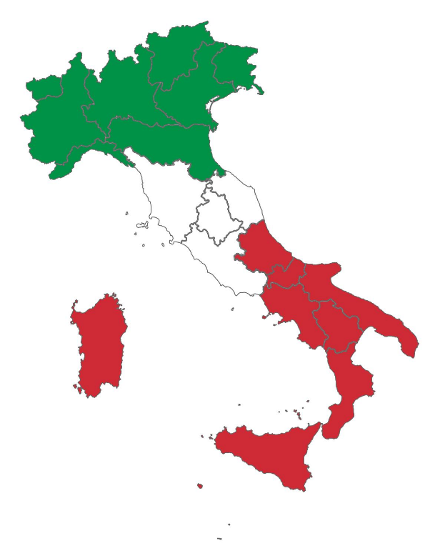 | ITALY IN ONE DISH  - RESTAURANT  LA QUINTA  SCUOLA ELEMENTARE PARONA
STARTERS  YORKSHIRE PUDDING £ 6.50  A typical British dish served with either chicken curry or with fish.  SEAFOOD SALAD £7.99  A classic Italian mixed seafood salad made with calamari, shrimp, clams, and scallops, and dressed in olive oil and lemon  MAIN COURSES  CHICKEN CURRY £12.99  Chicken breasts simmered in a spicy curry sauce with yoghurt, tomatoes, onion, garlic, and ginger and served with rice.  CHICKEN & CHIPS £ 10.50  A piece of barbecued chicken and chips, served with fresh vegetables.  CHICKEN WRAP £ 14.99  Crispy flour tortilla loaded with juicy chicken, bacon, lettuce, avocado and cheese, served with salad.  BAKED TROUT £ 15.99  A baked trout cooked in olive oil and lemon and seasoned with herbs. It is served with chips or asparagus. | FIRST COURSES  LASAGNA £ 7.50  A typical Italian pasta cooked in the oven with a Bolognaise sauce and white sauce topped with Parmesan cheese.  TAGLIATELLE WITH SALMON £7.50  Italian long pasta served with a sauce of salmon and cream.  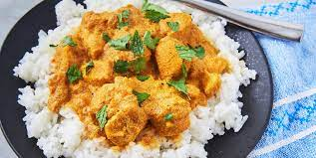  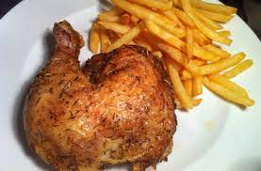  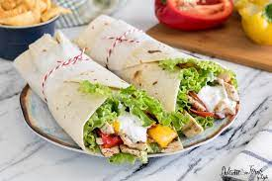  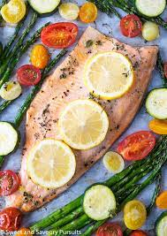
DESSERTS  ICE CREAM £ 4.99  Home-made ice cream in a variety of flavours. Choose from: chocolate, vanilla, strawberry, and lemon.  MACAROONS £1.99 EACH  A macaroon is a small cake made from ground almonds, coconut, and other nuts. Can be served with ice cream.  DRINKS  WATER £2.00  SPARKLING OR NATURAL  FIZZY DRINKS £ 3.50  COKE, FANTA, LEMONADE,  TEA £ 1.50  COFFEE £ 1.50 | TIRAMISU’ £4.99  Tiramisu is a coffee-flavoured Italian dessert. It is made of ladyfingers dipped in coffee, layered with a whipped mixture of eggs, sugar and mascarpone cheese.  APPLE PIE £4.99  An Apple Pie is a deep pie, consisting of several layers of apple slices packed in between two layers of crust. Another typical British dish and the perfect way to end the meal. Can be served with ice cream.  